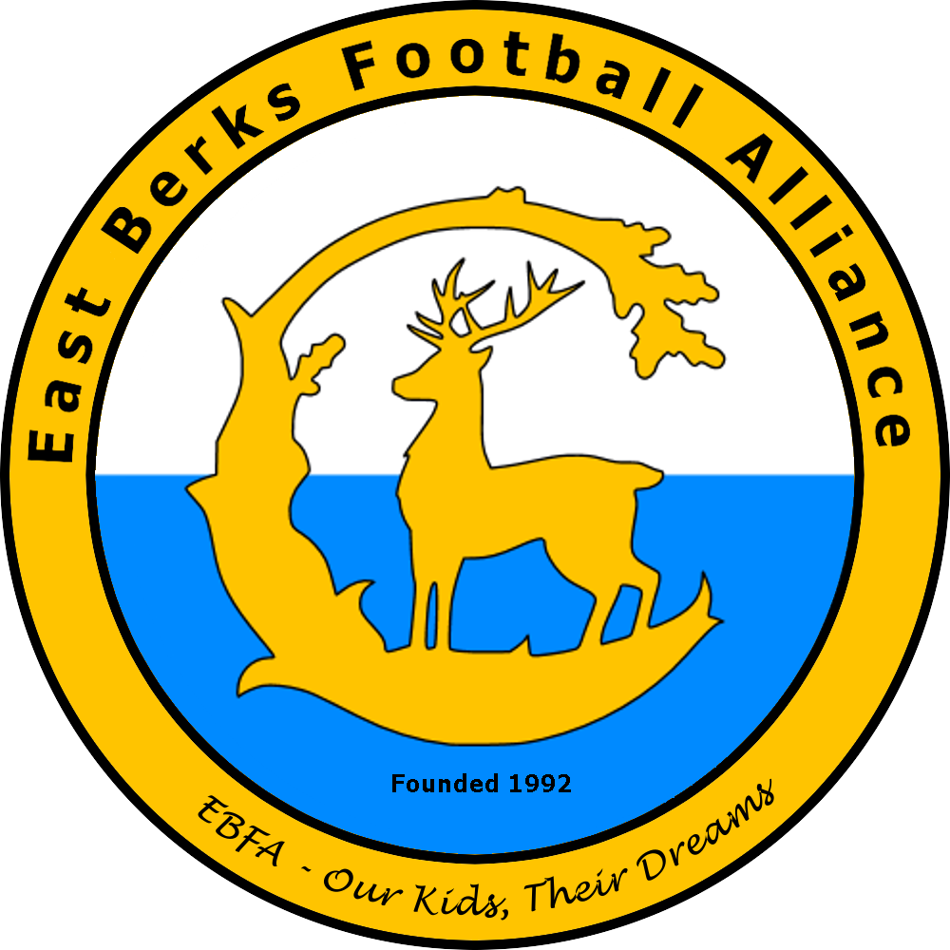East Berks Football Alliance

(EBFA - Our Kids – Their Dreams)

EBFA Match Check List 2022/23

EBFA Match Check List
As East Berks Football Alliance is a Charter Standard and Respect League, there are certain actions team managers and referees must undertake before a match.

Check list:

Home Team Managers/Responsible Adult

Match Details
- By 9pm on Sunday before the match - confirm details of the match, including kick off time, venue (directions), referee and their Qualified/Registered status. (See EBFA document EBFA Match Confirmation)
- If the home team is not able to arrange for a qualified/registered Referee then the away team has the option to arrange for a qualified/registered Referee to be the match official for the match.
- Request a confirmation reply to any text/email communication.
- If by Tuesday evening you have not had a confirmation reply from the away team – send a chasing email and a copy to the Club Secretary (details on www.eastberksfa.com)
- If by Wednesday evening you have not had a confirmation reply ring the Club Secretary of the opposition and let the Divisional Secretary know – DO NOT leave this all to Friday Evening.

Equipment
- Check Pitch, pitch markings, goal nets and corner flags etc.
- Make sure that the Respect Line/ Barrier for spectators is in place on the sideline.
- Provide the referee with at two correctly sized footballs fit for play and to the correct pressure. (Make sure there is a pump and pressure checker in your kit bag).
- Make sure you have a dedicated spectator area (across the pitch from the team officials) and that the Respect Barrier/Line for spectators is in place on the sidelines,
- Check that your team’s player equipment is not dangerous.
- Make sure your Captain is wearing the Respect arm band.
- Ensure your substitutes are wearing bibs or jackets during the match.

Opposition Team and Referee
- Greet opposing team & manager and show them any available dressing room facilities, and indicate the warm up area etc.
- Greet Referee and before the match pay fees, recovering 50% from the opposition. Ensure you have enough money to cover the full fee.
- Confirm with the Referee the age group and length of each half, plus details of extra time and penalties if a Cup match.
- For 9v9 and 11v11 matches ensure Clubs Linesmen you provide have sent a copy of the League’s document on ‘advice to a club linesman’.

Away Team Managers/Responsible Adult

Match Details
- Send confirmation of receipt to match confirmation details.

Equipment
- Check that your team’s player equipment is not dangerous.
- Make sure your Captain is wearing the Respect arm band.
- Ensure your substitutes are wearing bibs or jackets during the match.

Opposition Team and Referee
- Make yourself known to the home team manager as soon as you arrive to find out about any changing rooms and warm up areas etc.
- Pay the home team 50% of the Referee fee.
- Confirm the details of the Respect Line and the area for your spectators.
- Make yourself known to the Referee as soon as possible.
- 10 minutes before the kick off ensure your have provided the referee and opposition with the require team shetes

BOTH Team Managers/Responsible Adults – Before the Match

- 10 minutes before the kick off ensure your have provided the referee and opposition with the require team shetes
- Verify player Registration cards in accordance with League procedures, at least 10 minutes prior to kick off.

The Competition only approves the following two procedures for the verification of Player Identity cards before the commencement of the match:

- Within the penalty area of the Team being verified there shall only be the Team to be verified and the two Managers and a Management Committee official if present. The Team Manager of the players to be verified shall issue each player with their respective Identity Card. Each Player then presents their card to the opposition manager, who collects each card and returns them to the opposite Manager after receiving all Cards.

- Within the penalty area of the Team being verified there shall only be the Team to be verified and the two Managers and a Management Committee official if present. The Team Manager of the Team players to be verified shall give his card to the opposition Manager. The Team Manager of the Team players to be verified shall then call forward each player in card order for verification. The verifying Manager shall never be calling any of the opposition player’s names. At the end of the process the cards are returned.

At no time shall the players being verified be lined up in an identity style line up.

- If no ID cards are exchanged the match could be ruled null and void by the League.
- If either team does not have a their cards then
- If a team does not have their Registration cards then opposition team should ask for player’s names and date of births and submit to their Divisional Secretary after the match.
- For 9v9 and 11v11 matches introduce the Referee to your Club Linesman – the Club Linesman must have read the League’s Document – Club Linesman which covers their Responsibilities and provides tips on the Laws of the Game
(See EBFA document ebfa_clublinesman_helpful_hints.doc).
- With the Referee and Club Linemen organise the Respect handshake before the game starts.
- Ensure the Referee has a copy of the Group Age match Competition and the Referee Reporting on EBFA Matches Procedure.

BOTH Team Managers/Responsible Adults – After the Match

- Ensure the pitch is left clear and clean – litter must be removed.
- Ensure all players have appropriate transportation.
- By 19:00hrs on day of match, on the GotFootball system ensure the result of the match is enetered on the system.
- By 22:00hrs on Monday after the Saturday match, you must ensure you have completed, on the EBFA Google Forms system, the Team marks and Respect Report.

Referees

- On arrival make yourself known to both managers.
- The Home Manager will ensure your fee is paid before the match.
- Undertake the pitch checks including a check that there is a dedicated Spectator area and a Respect Barrier/Lines in place.
- 10 minutes before the kick off ensure you have been handed by both teams their respective team sheets.
- Check the players for equipment defects, jewellery etc.
- With the Team managers ensure the players undertake a Respect handshake just before the game starts.
- Ensure you has a copy of the Group Age match Competition and the Referee Reporting on EBFA Matches Procedure to be provided by both teams.

Jun-22

